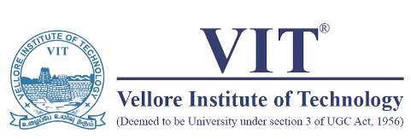
Grammar – Error Detection
Worksheet
Twenty-eight years after an English team last won a series in India, Alastair Cook and his inspired men pulled of a well-yearned and deserved 2-1 series triumph, following the drawn encounter at Nagpur on Monday. England also became the only team to had twice come back from a one-Test deficit to win series in India. The loss at Ahmedabad was a minor aberation from the well planned path England had planned. It was an early wakeup call and they came back hard at the hosts to leave them reeling in the following tests. David Gowers’ team was the last side from England to win a series in India – in 1984-85. This time, the fantastic turnaround had it’s own heroes. Cook, Kevin Pieterson, Jonathan Trott, Nick Compton, Matt Prior and Joe Root made runs at various stages. James Anderson, Steven Finn, Graeme Swann and Monty Panesar strangled the Indian batsmen with a wise-like grip. The Indian batting, baring Cheteshwar Pujara, Virendar Sehwag and Virat Kohli, lacks spine for battle. Sachin Tendulkar was a pale reflection of his batting might.
Puducherry Science Forum, in collaboration with the University of Paris, South, France are welcoming applications from students of Puducherry government schools, from Class VII to Class XII, to participate in the ‘Make Science 2013’ competition. The students can farm groups of not more than five members each. The University of Paris, France will select 12 projects for the finals and the finalists will receive a cash amount to carry out there experiments. Four of the best projects will be selected for the final price. The project awarded first place will receive a prize of 300 Euros and three second prizes will receive 100 Euros and a citation. The prescribed format for the project proposals can be obtained by sending an email to Puducherry Science Forum at cerdps@gmail.com. They must reach the Science Forum by December 21.

